- Employee Information
Employee Name: | Patricia Garcia |  | Employee ID #: | 21389
Review Period: | FY24 |  | Organization #: | 5400
- Annual Evaluation Results: Document performance including both results and behaviors.
Current Fiscal Year Major Objectives Agreed Upon With Manager |  | Current Fiscal Year Accomplishments
Embrace and Demonstrate the Core NREL Values:  - Collaboration – I have taken on a more active role within our center admin team in helping train and on-board new admins to NREL/our center which has given me the opportunity to engage and interactive more with my admin team. I also have communicated and worked with my supporting group more closely this year which has given me the chance to get to know them better on a personal level.  - Diversity, Equity, and Inclusion – I always try to treat everyone I interactive with internally and externally with respect, courtesy, equality and with a happy to help attitude. |  | - I have taken on an active role in assisting not only my manger but assisting my entire group with managing their calendar (manager only), meetings; travel arrangements, expense reports, event planning, etc.  - Coordinated frequently changing workflow processes that included: management approvals, Workday, Concur, Human Resources processes, ES&H, and IT requirements.  - We had several group members leave NREL this fiscal year, and I assisted them with the required departure process which includes ensuring that all NREL equipment is returned.  - I have completed all my assigned training in a timely manner.  - I continue to learn more about my role, the expectations, and how to better support/assist my group and manager. Not only those located locally but also outside of Colorado.  - I am one of the more senior admins in our center, so I have helped onboard several new admins. Duties include training, mentorship, overall guidance, back up support for other groups in our center, and event plannings.  - I am back up support for onboarding interns when they arrive to NREL not only for our group but other groups as well. This is a very lengthy and entail process which requires months of planning.
Other Major Accomplishments:
- N/A

- Manager Feedback
Manager Feedback:
- Overall, it has been a real pleasure having Patricia as the BSP for our team. Her efforts have tremendous impact. She has helped all of us, and especially me, successfully navigate the complexities of the NREL system with little friction which, in turn, enables us to focus on our work and deliver high quality results.
- Given this year was a transition year for me, there was much I had to learn to become a successful manager. Patricia has gone to extraordinary lengths to ensure my transition was smooth and supported me with the tools, background, and information I needed.
- Patricia also brings a phenomenal attitude to work and to the team. Her positive and upbeat attitude are infectious and it makes everyone feel included and welcomed. These are attributes that are essential to foster strong team bonds.

Peer review feedback and suggestion for improvement, if any:
- Patricia’s dedication to providing excellent customer service is evident in every interaction. She is thorough, detail-oriented, and always willing to go the extra mile to ensure the success of any project she assists with. Patricia is the unsung hero of our team, working behind the scenes to keep everything running smoothly. Her efforts often go unnoticed, but her impact is undeniable.
- Patricia is always a joy to be around. She is helpful, resourceful and always lends a helping hand. I always look forward to opportunities to work with her. She has shown me various areas for improvement in a kind and courteous manner.
- Patricia accomplishes all BSP duties efficiently. She is willing to assist others with whatever is needed. Patricia is very friendly and compassionate with all she works with and I truly enjoy working with her.
- One area where Patricia could continue to grow is in building more confidence in showcasing her work. Her contributions are substantial, and sharing them more visibly would allow others to better appreciate her skills and expertise.

- Major Performance Objectives for Next Fiscal Year: State your major objectives for next year.
- To learn and integrate more with my team which will allow me to provide better support and assistance to them and to my manager on a day-to-day basis.

- To continue to learn more about what NREL is developing on how we use, consume, store, and generate energy to improve the quality of our planet.

- To continue developing, strengthening, and keeping my skill set up to date with the latest software changes. Still a work in progress.

- I continue working on my communication skills.

- Areas for Growth, Development and Challenge: List skills to be developed or strengthened.
To continue to work on my technical skills and to become pro-active on how I can support my manager and team which will enable them to spend more time on other work/project matters.
- Overall Performance Rating:
Enter the overall performance rating here:
Exceptional

Type “Yes” in the box to the left if a corrective action plan is required.

Performance Rating Definitions:
Needs improvement – Employee does not meet the performance and/or behavior expectations, and/or demonstrates only a minimum level of proficiency in the competencies required in his or her job on a consistent basis. This rating also applied to an employee who may exhibit workplace behaviors which negatively impact the ability to be effective in his or her role, although goals may be achieved. Additional skill development, commitment, and/or change in behaviors are necessary. This rating describes the employee who may meet only the very minimum position requirements and/or behaviors and change is necessary. The evaluation should detail the changes necessary for improvement to ensure clear expectations are defined.

Successfully meets or exceeds expectations – Employee is currently successful in his or her role and consistently meets and may frequently exceed the high NREL performance expectations commensurate with his or her position within the laboratory. The expected behaviors include proficiency regarding judgment, interpersonal and communication skills, and other competencies required in his or her job. This rating describes the employee whose overall performance is successful and above. Any minor areas where performance gaps exist were counterbalanced by overall successful performance and behavior that consistently met or exceeded expectations. The rating can also apply to employees new in their jobs who may be learning or lack experience but, overall, are successful in their role with no significant gaps in performance or behavior.

Exceptional – Employee consistently exceeds the majority of performance expectations and goals, and demonstrates judgment and behaviors commensurate with their position within the laboratory. The expected behaviors include a high level of proficiency regarding judgment, interpersonal and communication skills, and other competencies required in his or her job.

- Compliance (Please initial)
Manager: Print copy and have employee complete section below,
Employee: Mark the appropriate box for each item below.

Circle the appropriate response | Initial each item below
Yes / No | PG | I have reviewed the Commitment to Safety and Environmental Stewardship and my EHS training requirements with my manager.
Yes / No | PG | I have discussed the relevant Human Resources training requirements with my manager.
Yes/No | PG | I have discussed standards of conduct with my manager and understand my responsibilities in these areas.
Yes / No | PG | I have discussed cyber security requirements, including personally identifiable information (PII) and physical security requirements, including visitor access and control issues, with my manager and understand my responsibilities in these areas.

- Employee Comments (Optional)
- Signatures

Employee: | Patricia Garcia |  | Date: | 12/11/2024
Employee’s Manager: | Mark Chung |  | Date: | 12/11/2024

Reviewing Manager: | 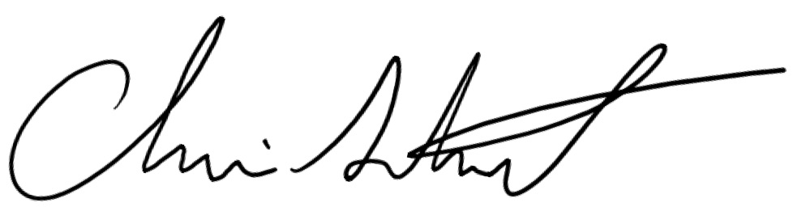 |  | Date: | 12/16/2024

